1. **Created a project on GKE(NAGP-lokendrakumar)**

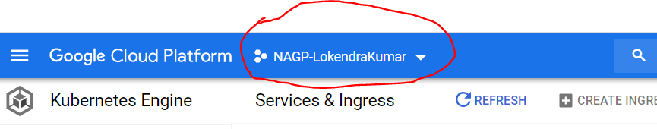

1. **Created a GKE cluster with name im-cluster-nagpmicroservices**

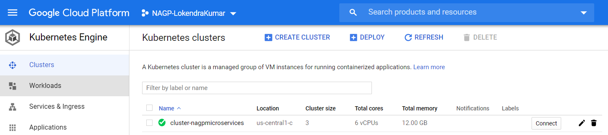

1. **Connect google cloud CLI with cluster:**

gcloud container clusters get-credentials cluster-nagpmicroservices --zone us-central1-c --project NAGP-LokendraKumar

1. Login into docker using CMD

docker login -u lokendrakumar -p <pwd>

1. **Deployed single instance SQL Server 2017 on GKE**
   1. Created a Kubernetes secret

kubectl create secret generic nagp-secret --from-literal=SA_PASSWORD=<PWD>

* 1. Created the StorageClass and PersistentVolumeClaim

kubectl create -f sqlserver-volume.yaml

* 1. Setting up and deploying SQL Server

kubectl create -f sqlserver-deployment.yaml

1. **Deploy Order Service** 
   1. Created a docker image for Order service using the below command from the project directory

docker build -t orderservice:dev .

* 1. Tag local image to docker image.

docker tag orderservice:dev lokendrakumar/nagp-order-reg:v1

* 1. PUSH image to Container registry.

docker push lokendrakumar/nagp-order-reg:v1

* 1. Create Pods for Order service on GKE.

kubectl apply -f orders-api-deployment.yaml

* 1. Create Service for Order API on GKE

kubectl apply -f orders-api-service.yaml

1. **Deploy User Service** 
   1. Created a docker image for user service using the below command from the project directory

docker build -t userservices:latest .

* 1. Tag local image to docker image.

docker tag userservice:dev lokendrakumar/nagp-user-reg:v1

* 1. PUSH image to Container registry.

docker push lokendrakumar/nagp-user-reg:v1

* 1. Create Pods for Order service on GKE.

kubectl apply -f users-api-deployment.yaml

* 1. Create Service for Order API on GKE

kubectl apply -f users-api-service.yaml

1. **Deploy Aggregates Service** 
   1. Created a docker image for aggregate service using the below command from the project directory

docker build -t orderdetailsapigateway:dev .

* 1. Tag local image to docker image.

docker tag orderdetailsapigateway:dev lokendrakumar/nagp-orderdetails-reg:v1

* 1. PUSH image to Container registry.

docker push lokendrakumar/nagp-orderdetails-reg:v1

* 1. Create Pods for Order service on GKE.

kubectl apply -f apigateway-deployment.yaml

* 1. Create Service for Order API on GKE

kubectl apply -f apigateway-service.yaml

Jaeger service Deployment

**kubectl create -f https://raw.githubusercontent.com/jaegertracing/jaeger-kubernetes/master/all-in-one/jaeger-all-in-one-template.yml**